**Health Al: Intelligent**

**Healthcare AI Assistant**

**Project Documentation**

# Introduction

* + Project title : Health Al: Intelligent Healthcare AI Assistant
  + Team member :JANANI S
  + Team member :KAMATCHI D
  + Team member :KAVIYA P
  + Team member :LAVANYA S

# Project overview

* + **Purpose** :

Empower healthcare providers and patients to thrive in a more data-driven and personalized health environment. Utilize AI and real-time data to optimize diagnostics, treatment planning, and patient engagement, while supporting clinicians with actionable insights and summarizations.

# Features:

**Conversational Interface**: Natural language health queries and advice - Diagnostic Summarization: Converts clinical reports into easy-to-understand summaries

**Dashboard Visualizations**:

Tracks patient metrics and KPIs in real time - Feedback Loop: Collects user and clinician feedback for system refinement

**Predictive Analytics**:

Forecasts patient outcomes, resource needs, and identifies anomalies in health data - Multimodal Inputs: Supports data, PDFs (health records), and CSV uploads (lab reports)

# Architecture

-**Frontend (Stream lit or Gradio)-**

Interactive web UI for dashboards, chat, file uploads (health data), feedback forms, and report viewing- Modular pages for scalability and ease of navigation

# -Backend (Fast API)-

API endpoints for health data processing, chat interactions, report generation, vector embedding for clinical document search- Asynchronous handling for real-time responsiveness

**-LLM Integration (IBM Watsonx Granite)-** Generates health advice, summaries, and recommendations using prompts

Vector Search (Pinecone)- Embeds health documents (e.g., clinical notes) for semantic search and contextual retrieval

# Vector Search (Pinecone)-

Embeds health documents (e.g., clinical notes) for semantic search and contextual retrieval

**ML Modules (Forecasting and Anomaly Detection)-** Models predict patient outcomes and flag unusual readings (e.g., vital sign spikes, lab result anomalies)

# Setup Instructions-

Same as original, but with emphasis on secure handling of personal health information and compliance with healthcare regulations

# Folder Structure-

Adapt app/, app/ api/, ui/, main dashboard script, LLM handler, embedder, forecaster, anomaly checker, and report generator for health contexts

# Running the Application-

Launch backend and frontend, upload health documents, interact via chat, and view health reports and predictions

1. **API Documentation-** POST /chat/ask:

Health-related questions and advice- POST

/upload-doc: Embed clinical documents- GET /search-docs: Return similar patient cases, studies, or guidelines- GET /get- health-tips: Personalized health advice- POST /submit-feedback: Collects user feedback.

1. **Authentication-** Support for JWT, OAuth2 (with healthcare provider credentials), and role-based access (doctor, patient, researcher).
2. **User Interface-** A user interface(UI) for a Health AI project should be designed for simplicity, accessibility, security and clarity, making complex health data actionable for both clinicians and patients. Minimalist, with special attention to accessibility for all patients- Sidebar with navigation; KPI cards showing patient’s current metrics; tabs for chat, tips, and forecasts- Downloadable health reports.

**10.Testing -** Health AI project involves validating the system to ensure it is accurate, reliable, and safe for real-world use. This process includes statistical validation of the AI’s predictions, evaluation of clinical utility, and monitoring for unintended risks and ethical concerns.

**Purpose of Testing-**The main goal is to confirm whether the AI model performs well in terms of accuracy, robustness, and consistency across diverse datasets and scenarios. Clinical testing should demonstrate that the technology improves patient outcomes and integrates smoothly into healthcare workflows.

**Key Testing Steps-** Validate AI predictions using various data sets to assess statistical performance, reliability, and real-world generalizability. Evaluate clinical effectiveness by running experiments in real- time environments and comparing results with standard practices. Ensure economic utility so that the investment in AI delivers measurable benefits relative to costs. Ongoing Monitoring Once deployed, the AI system must be continuously monitored to detect risks, adverse events, and maintain high performance. Feedback loops and stakeholder engagement are critical in identifying issues and facilitating improvements through iterative experimentation

# Screenshots:

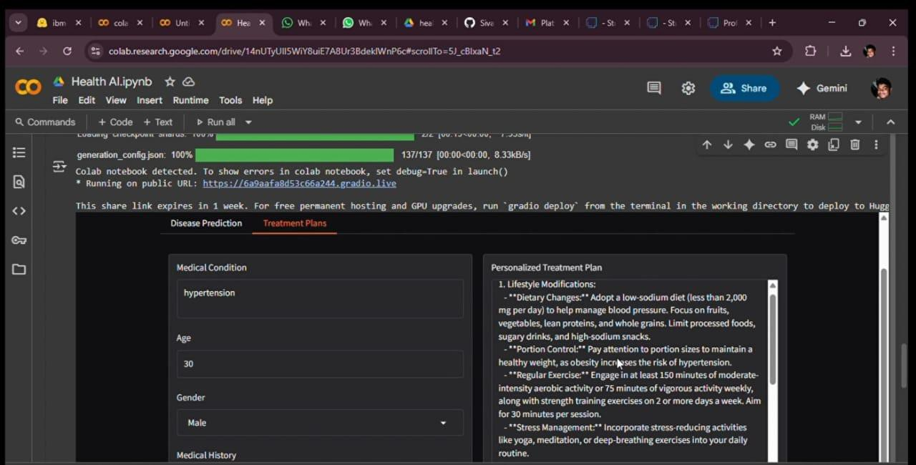

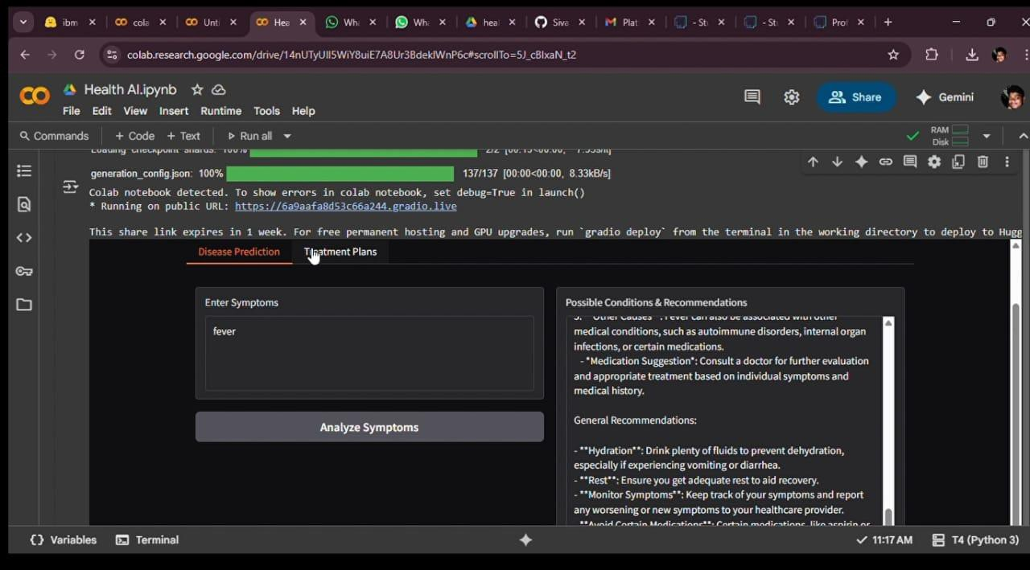

1. **Known Issues-** Data privacy and

compliance (HIPAA/GDPR)- Handling malformed health inputs or corrupted files - Model bias or inaccuracies in recommendations - System latency for large health datasets- Limited support for rare clinical formats or local language documents- Need for ongoing human supervision to validate AI outputs .This structure ensures the Health AI project documentation aligns with industry best practices, provides clarity for both technical and non-technical users, and allows for robust future development and troubleshooting

1. **Future Enhancements-**

Integration with wearables (real-time patient monitoring) - Prescription summarization and alerts for drug interactions- Automated appointment and follow-up reminders- Advanced anomaly detection (rare disease flagging)- Expansion to include mental health Role- based dashboards for doctors, nurses, patients, and administrators and remote consultation analytics

# Conclusion:

Health AI project should emphasize both the transformative potential and the necessary precautions surrounding artificial intelligence in healthcare. AI can improve the accuracy of diagnoses, personalize treatments, empower patients, and streamline decision-making, ultimately enhancing care quality and reducing errors and costs. However, successful integration also demands addressing substantial challenges including ethical concerns, data privacy, security, regulatory compliance, and the need for ongoing education and collaboration among stakeholders